Solar System or Planet Project
You are learning about the solar system and models in science class. In order to show what you have learned you can choose from either project listed below. These projects will be used as a test grade, so make sure to do your best. All projects are due no later than December 11th.
Projects to Choose From:
- Solar System Project: You will create your own solar system model to display in our classroom. I encourage you to be creative. Here are the basic rules:
  - You must have the Sun and all 8 planets.
  - The Sun needs to be the biggest object. Try to keep the planets in proportion. In other words, Earth should not be larger than Jupiter.
  - All objects must be labeled correctly and where I can easily read it.
  - You may use anything you like to do the project. A coat hanger, a box, dowel rods, Styrofoam balls, food, whatever you like!
  - See the rubric attached to help you figure out what project will deserve a “4”. If you need supplies or help with the project, be sure to ask me. I will help however I can, but don’t wait until the last minute.
Examples:
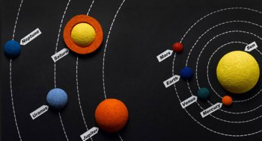
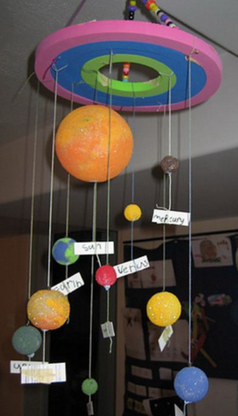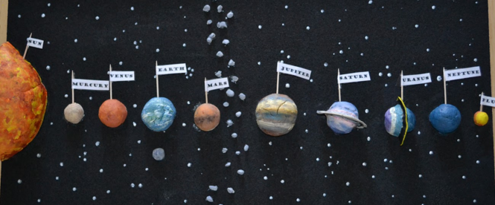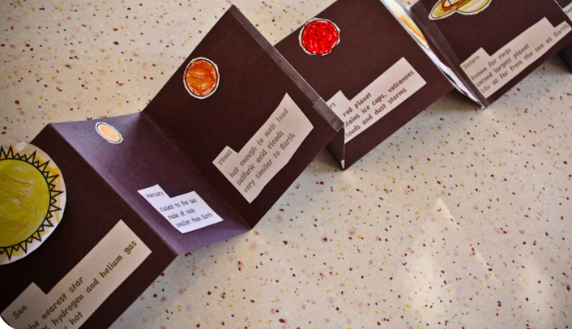
- Planet Research Project: You will pick a planet to research and create a poster, power point, Prezi, etc to present to the class. See the rubric attached to help you figure out what project will deserve a “4”. If you need supplies or help with the project, be sure to ask me. I will help however I can, but don’t wait until the last minute. Research projects can be emailed to Mrs. Vasilion at avasilio@hpsk12.net

Turning projects in early is encouraged!

Solar System Project Rubric:
 | Excellent (20 pts) | Good (17 pts) | Fair (14 pts) | Poor (10 pts)
Creativity | Student showed large amounts of creativity. All planets are the correct color and imagination has been used when designing the model. | Thought has been put into the project. The planets are close to the correct color and there is evidence of student effort. | Some thought has been put into the project. There is some color and a few planets are colored incorrectly. | Very little or no creativity. No color is used or the planets are colored incorrectly.
Planets | All planets are accounted for. | One planet is missing. | Two planets are missing. | Three or more planets are missing.
Proportion/Scale | All of the planets are roughly proportional to each other. | Most of the planets are proportional to each other. | There are a couple of mistakes with the proportions of the planets. | Planets are not correctly proportioned.
Labels | All planets are correctly and clearly labeled. | All planets are correctly labeled, but are difficult to read or find. | Planets are incorrectly labeled or the labels are almost impossible to read. | Planets are not labeled or the labels are impossible to read.
Order | All the planets are in the correct order. | One or two planets are out of order. | Three or more planets are out of order. | Four or more planets are in the wrong order.

Planet Research Project:
These items need to be included in your presentation:
- Name of Planet
- Size
- Color(s)
- Distance from the sun
- What does its name mean? (Many planets got their name from a mythological god.)
- Position in the Solar System: ________ planet from the sun
- Orbit: How long does it take your planet to travel around the sun?
- Length of a day: How long is a day, or one rotation, on your planet?
- Temperature: How hot or cold is your planet?
- How many moons does it have? How many rings does it have?
- What is your planet made of (rocks, gases, etc.)?
- Who discovered the planet? ______________________________ When?
- List three interesting facts you found about your planet that you have not written down yet.
- Picture of your planet
Planet Research Project Rubric:
_____/5 Name of the planet
_____/5 What does your planet’s name mean?
_____/10 Color illustration of the planet
_____/10 Description of the planet: including what the planet is made of, surface temperature, and atmosphere
_____/10 Size of the planet and position in the solar system
_____/ 5 Distance from the sun
_____/5 Description of any moons or rings, if none – please write none. Name of moons
_____/5 Length of the day on the planet
_____/ 5 Length of the year on the planet
_____/15 When and who discovered the planet?
_____/ 5 Three interesting facts about your planet
_____/10 Neatness, Effort, Work Ethic, and Organization – Organize the information neatly on the poste or presentation.
_____/10 Grammar, Spelling, Correctness of Information

_____/100 TOTAL SCORE

